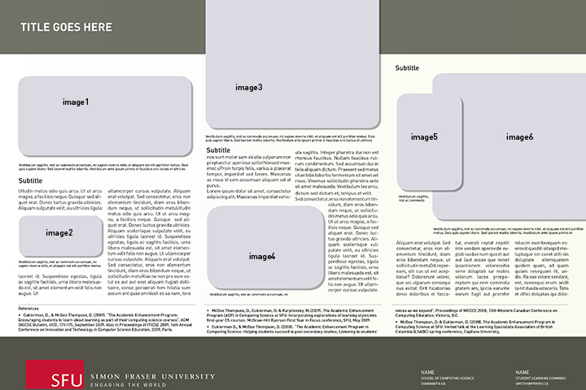

INSTRUCTIONS:

Please include the following sections and content:

Title of Project

Name(s), title and department(s) of instructor(s) involved in the project

Body: 575 words max. (including references)

Please divide your research summary into five sections:

• Questions that were investigated (taken from your proposal)
• Context (eg. course/program)
• Summary of findings organized by questions that were investigated
• Next steps (e.g., how you will apply findings to your teaching)
• References

Names of 6 images and accompanying captions

IMAGES:

This template works best with 6 images. Please send us 6 images in jpeg or tiff format, as an attachment to your email. Please name the images so that they correspond with your captions in your word document.

Image 1- must be about 20-22 inches wide, height is adjustable, but around 10-12 inches. 300 dpi

Image 2- must be about 10 inches wide, height is adjustable, but around 5 inches. 300 dpi

Image 3- must be about 20-22 inches wide, height is adjustable, but around 22 inches. 300 dpi

Image 4- must be about 10- 14inches wide, height is adjustable, but around 10 inches. 300 dpi

Image 5- must be about 7-8 inches wide, height is adjustable, but around 12 inches. 300 dpi

Image 6- must be about 20-22 inches wide and adjustable, height is adjustable, but around 18 inches. 300 dpi

---------WORD TEMPLATE---------

TITLE OF POSTER- Header One
AUTHOR NAME
AUTHOR SCHOOL AND EMAIL

Subtitle- Header 2

Uitudin metus odio quis arcu. Ut ut arcu magna, a facilisis neque. Quisque sed aliquet erat. Donec luctus gravida ultricies. Aliquam sulputate velit, eu ultricies ligula

laoreet id. Suspendisse egestas, ligula ac sagittis facilisis, urna libero malesuada est, sit amet elementum velit felis non augue. Ut
ullamcorper cursus vulputate. Aliquam erat volutpat. Sed consectetur, eros non elementum tincidunt, diam eros bibendum neque, ut sollicitudin metuUitudin metus odio quis arcu. Ut ut arcu magna, a facilisis neque. Quisque sed aliquet erat. Donec luctus gravida ultricies. Aliquam scelerisque vulputate velit, eu ultricies ligula laoreet id. Suspendisse egestas, ligula ac sagittis facilisis, urna libero malesuada est, sit amet elementum velit felis non augue. Ut ullamcorper cursus vulputate. Aliquam erat volutpat. Sed consectetur, eros non elementum tincidunt, diam eros bibendum neque, ut sollicitudin metuRiae ne non pro eum volut es aut aut eost aliquam fugiati dollitaere, conse poriaerati tem hitatia sum accum ent quae omnissit es sa nam.

Subtitle- Header 2

reptaectur aperiosa sollorNonsed maximol uProin turpis felis, varius a placerat tempor, imperdiet sed lorem. Maecenas ac risus id sem accumsan aliquam vel et purus.

Lorem ipsum dolor sit amet, consectetur adipiscing elit. Maecenas imperdiet vehicula sagittis. Integer pharetra dui non est rhoncus faucibus. Nullam faucibus rutrum condimentum. Sed accumsan dui in felis aliquam dictum. Praesent sed metus vitae felis lobortis fermentum sit amet vel risus. Vivamus sollicitudin pharetra ante sit amet malesuada. Vestibulum leo arcu, dictum sed dictum et, tempus et velit.
Sed consectetur, eros non elementum tincidunt, diam eros bibendum neque, ut sollicitudin metus odio quis arcu. Ut ut arcu magna, a facilisis neque. Quisque sed aliquet erat. Donec luctus gravida ultricies. Aliquam scelerisque vulputate velit, eu ultricies ligula laoreet id. Suspendisse egestas, ligula ac sagittis facilisis, urna libero malesuada est, sit amet elementum velit.

Subtitle- Header 2

felis non augue. Ut ullamcorper cursus vulputate. Aliquam erat volutpat. Sed consectetur, eros non elementum tincidunt, diam eros bibendum neque, ut sollicitudin metuOdi repernam, siti cus ut est aceptiatur? Dolorerunt velest, que asi ulparum consequi nus eictat. Orit hicaborias dessi doloribus et faccatur, eserati reptat repelit inte vendam aperovide explab iusdae num quo et aut aut laut accae que nonet ipsantionem voloressitia sime doluptati iur moles volorum lacea prorporeptam qui rem commolu ptatem am, ipiciis earunte earum fugit aut prorehe nducim exeribeaquam eserovid quoditi sitaspid moluptaque sin conet aliti nis doluptate sitemquatem quidem quam, ad quam quiam resequam lit, undio. Ra sae volore sendant, est, nonsequo erum andit

Reference header:

• Reference style
•Cukierman, D., & McGee Thompson, D. (2009). “The Academic Enhancement Program: Encouraging students to learn about learning as part of their computing science courses”. ACM SIGCSE Bulletin, 41(3), 171-175, September 2009. Also in Proceedings of ITICSE 2009, 14th Annual Conference on Innovation and Technology in Computer Science Education, 2009, Paris.
•McGee Thompson, D., Cukierman, D. & Karpilovsky, M.(2009). The Academic Enhancement Program (AEP) in Computing Science at SFU: Incorporating explorations of learning styles into first-year CS courses. McGraw-Hill Ryerson First Year in Focus conference, SFU, May 2009.
•Cukierman D., & McGee Thompson, D. (2008). “The Academic Enhancement Program in Computing Science: Helping students succeed in post-secondary studies; Listening to students’ voices as we expand”. Proceedings of WCCCE 2008, 13th Western Canadian Conference on Computing Education, Victoria, B.C.
•McGee Thompson, D. & Cukierman, D. (2008). The Academic Enhancement Program in Computing Science at SFU. Invited talk at the Learning Specialists Association of British Columbia (LSABC) spring conference, Capilano University, May 2008.

